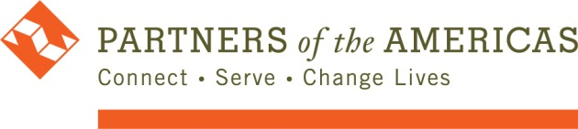
Policy & Procedure

IT & Communication Reimbursement Policy During COVID-19 Work From Home Restrictions

Effective January 1, 2021

Purpose
The purpose of this policy is to help offset some IT and communications-related costs required to perform your Partners of the Americas job remotely during the COVID 19 pandemic.

2. Scope
This policy applies to all Partners of the Americas employees, contractors and interns who normally work at the HQ office in Washington, DC.

3. Procedure
- All employees will receive a reimbursable payment of $24 for every pay period beginning January 15, 2021 through Paycom. This reimbursement will continue for the duration of 2021.
- Approved contractors and interns may request reimbursement on their monthly invoice. Interns will be eligible for the reimbursement if stipulated in the intern agreement. Interns that do not have the reimbursement stipulated in the intern agreement, may also be eligible upon written approval from the President & CEO
- This policy is at the discretion of the President & CEO with guidance from the SLT and may be terminated or modified from time to time.

